Written by Tiffany Floyd

301 words

**Droubi, Hafidh al-** (1914-1991) Born in Baghdad, Iraq

Hafidh al-Droubi is considered an important figure in the development of art education in Iraq as he held important posts like the Deanship of the Academy of Fine Arts in Baghdad and the Chair of the Society of Iraqi Plastic Arts. He was also a prolific painter that experimented with and excelled at various modes of representation. As a leading artist of the pioneer generation, al-Droubi was one of the first Iraqi artists to study art abroad, first at the *Accademia Reale* in Rome and then at Goldsmiths College in London. He also instituted Iraq’s first free art studio that gave young artists a space to practice and interact. This idea grew into a network of successful ateliers. Furthermore, al-Droubi was a founding member of Iraq’s first official art group, the Society of the Friends of Art established in 1941. The painter also founded his own artist collective, the Impressionists, in 1953 that could better serve his own pedagogical concerns. Largely made up of al-Droubi’s students, the Impressionists worked towards a shared attitude towards art education rather than a specific style. Al-Droubi was an active exhibitor showing artworks in almost all major shows held by the Society of the Friends of Art and the Impressionists. He has also participated in international exhibitions both in Europe and around the Arab world. He was honored at the 1972 Al-Wasiti Festival, one of only a few artists to garner special recognition.

**Resources and further reading**

Ali, Wijdan. *Modern Islamic Art: Development and Continuity*. Gainsville: Florida University

Press, 1997.

*Barjeel Art Foundation Online*. <http://www.barjeelartfoundation.org/>. Last Modified December

2013. http://www.barjeelartfoundation.org/artist/iraq/hafidh-aldroubi/

El-Husri, Khaldun. “The Wanderer: A Study of Modern Iraqi Painting” *Middle East Forum* 4

(1958), 23-27. <http://artiraq.org/maia/items/show/184>, (accessed September 2 2011).

**Faraj, Maysaloun, ed.** ***Strokes of genius: Contemporary Iraqi art*.** London: Saqi Books, 2001.

*Modern Art Iraq Archive*, <http://artiraq.org/maia/>

Naef, Silvia. “Reexploring Islamic Art: Modern and Contemporary Creation in the Arab World and Its Relation to the Artistic Past.” *RES: Anthropology and Aesthetics* 43 (2003), 164-174.

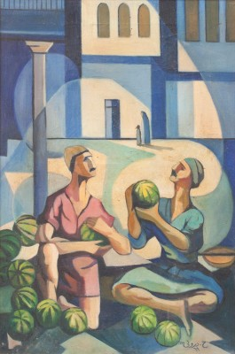

Hafidh al-Droubi

*Watermelon Sellers*, 1969

Oil on canvas

61 x41 cm

Meem Gallery, Dubai